**KENDRIYA VIDYALAYA TAMENGLONG**

**F.A.-III, (2015-16)**

**EVS CLASS-IV**

**NAME OF THE STUDENT-………………………………..…………………… MAX.M.- 40**

**ROLL NUMBER-……… TIME- 90 MINUTE**

|  |  |  |  |  |
| --- | --- | --- | --- | --- |
| **COMPETENCY** | **O & R** | **I & C** | **D. F.** | **TOTAL** |
| **MAX. MARKS** | **10** | **15** | **15** | **40** |
| **MARKS OBTAINED** |  |  |  |  |
| **GRADE** |  |  |  |  |

**EXAMINER’S SIGN…………………………………. INVIGILATOR SIGN………………………………**

# OBSERVATION AND REPORTING

**Q.1. Observe the pictures carefully and write one sentence about it.**

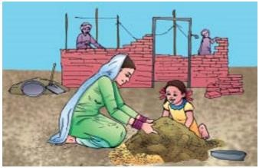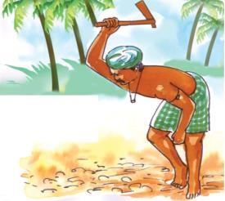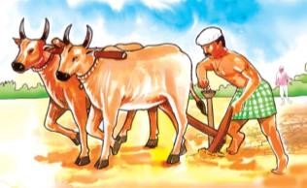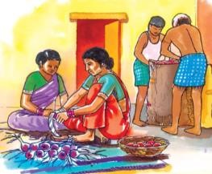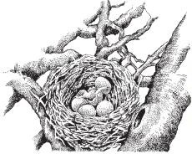

1. Ans. ……………………………………………………………………………………………………….
2. Ans. ……………………………………………………………………………………………………………
3. Ans. ……………………………………………………………………………………………
4. Ans. …………………………………………………………………………………………………………….
5. Ans. ……………………………………………………………………………………………

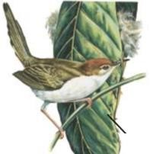 Ans. ……………………………………………………………………………………………

**Q.2. i) Look at the pictures and mark them in the correct order.**

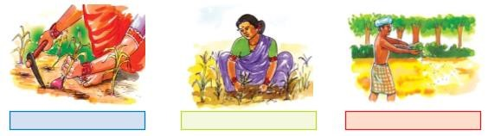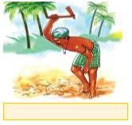

ii) What should we do if we have diarrohea and vomiting ?

**Ans** ……………………………………………………………………………………………………………………………………………………

……………………………………………………………………………………………………………………………………………………

……………………………………………………………………………………………………………………………………………………

# IDENTIFICATION AND CLASSIFICATION (MARKS-15)

Q.3.i) Match the following according to the places where the birds make their nests:

(a) Dove high up on a tree

(b) Indian Robin in or around our house

(c) Crow old buildings

(d) Sparrow between the stones

(e) Pigeon Courtyard,throns

1. Write the names of the implement.

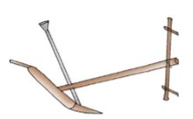

Name (in this chapter) …………………………….

Name in your area ………………………………

Work ……………………………………………………………..

1. How it helps a bird?

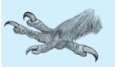 ……………………………………………………………………………..

1. What do you know about :-
2. Bihu ……………………………………………………………………………………………………………………………………………………………………………

…………………………………………………………………………………………………………………………………………………

1. BhelaGhar ……………………………………………………………………………………………………………………………………………………………………………

……………………………………………………………………………………………………………………………………………..

**ii**) Identify the vegetables/fruits and colour them.

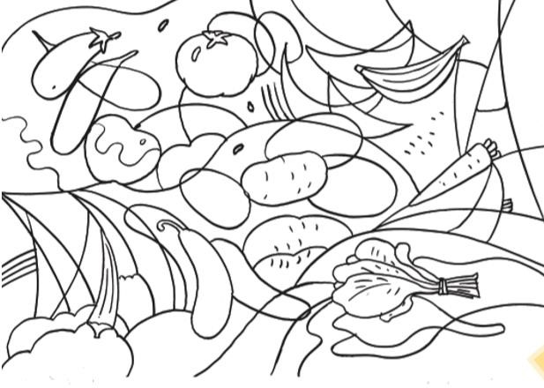

A list of vegetables is given below. Write the names of the vegetables /fruits in the correct column**.**

Spinach Potato Banana Tomato Pear

Chikoo Pineapple Gourd Onion Cabbage

Cucumber Grapes Ginger

|  |  |  |  |
| --- | --- | --- | --- |
|  | **Fruits and vegetables that spoil quickly** |  | **Fruits and vegetables that can stay for some days** |
| ………………………………………………………………………………  ……………………………………………………………………………….  ……………………………………………………………………………….  …………………………………………………………………………………  ……………………………………………………………………………….. | | ……………………………………………………………………………..  ……………………………………………………………………………..  ……………………………………………………………………………..  ……………………………………………………………………………….  ………………………………………………………………………………. |

# DISCOVERY OF FACTS (MARKS-15)

Q.4 Fill in the blanks :

(a) Illige is a …………………… tool used to cut the dried leaves.

(b) The pea plant has a ……………… stem.

(c) Deasert oak tree is found in ………………………………

Q.5 (a) Why did Nandita come to Mumbai ?

Ans: …………………………………………………………………………………………………………..

…………………………………………………………………………………………………………………

1. Who came to receive them on the station ?

Ans: ……………………………………………………………………………………………………..

Q.6 Write few sentences about desert plant ?

Ans: …………………………………………………………………………………………………………….

……………………………………………………………………………………………………………………

……………………………………………………………………………………………………………………

………………………………………………………………………………………

Q.7 What did Raziya read in the newspaper ?

Ans: ………………………………………………………………………………………….......................

……………………………………………………………………………………………………………………

……………………………………………………………………………………………………………

Q.8 Write any five uses of water:

Ans: 1.

2.

3.

4.

5.

Q.9 Draw the picture of different kinds of bird’s beaks :

**KENDRIYA VIDYALA TAMENGLONG**

**F.A.-III, (2015-16)**

**EVS CLASS-IV**

**NAME OF THE STUDENT-………………………………..…………………… MAX.M.- 40**

**ROLL NUMBER-……… TIME- 90 MINUTE**

|  |  |  |  |  |
| --- | --- | --- | --- | --- |
| **COMPETENCY** | **O & R** | **I & C** | **D. F.** | **TOTAL** |
| **MAX. MARKS** | **10** | **15** | **15** | **40** |
| **MARKS OBTAINED** |  |  |  |  |
| **GRADE** |  |  |  |  |

**EXAMINIER’S SIGN……………………… INVIGILATOR SIGN………………………………**

**KENDRIYA VIDYALA TAMENGLONG**

**F.A.-III, (2015-16)**

**EVS CLASS-V**

**NAME OF THE STUDENT-………………………………..…………………… MAX.M.- 40**

**ROLL NUMBER-……… TIME- 90 MINUTE**

|  |  |  |  |  |
| --- | --- | --- | --- | --- |
| **COMPETENCY** | **O & R** | **I & C** | **D. F.** | **TOTAL** |
| **MAX. MARKS** | **10** | **15** | **15** | **40** |
| **MARKS OBTAINED** |  |  |  |  |
| **GRADE** |  |  |  |  |

**EXAMINIER’S SIGN……………………… INVIGILATOR SIGN………………………………**